Library General Information:  - Students are allowed access to the library during class time; only with a signed pass from their teacher. Before school, at lunch and after school, all students have access.  - The library is staffed by one full-time Librarian.  - The Library may be closed when reserved by classes or for other official school business.  - The Library will be open during both lunches most school days.  Tiger Skills  Delano High School expects that each day, in every classroom, and in every co-curricular setting, all students exemplify three fundamental attributes valued in our school community.  DEVELOP ACADEMIC EXCELLENCE  HAVE EFFECTIVE COMMUNICATION SKILLS  SHOW PERSONAL RESPONSIBILITY | Tiger Library  The Delano High School Library is committed to ensuring that all students are effective thinkers and creators of ideas and information  Hours of Operation  Monday – Friday 7:30a.m – 4:00p.m  Lunch – 1:00 – 1:30 (may vary)  Staff: Raquel Briseño, Librarian  Email Mrs. Briseño @ rbriseno@djuhsd.org  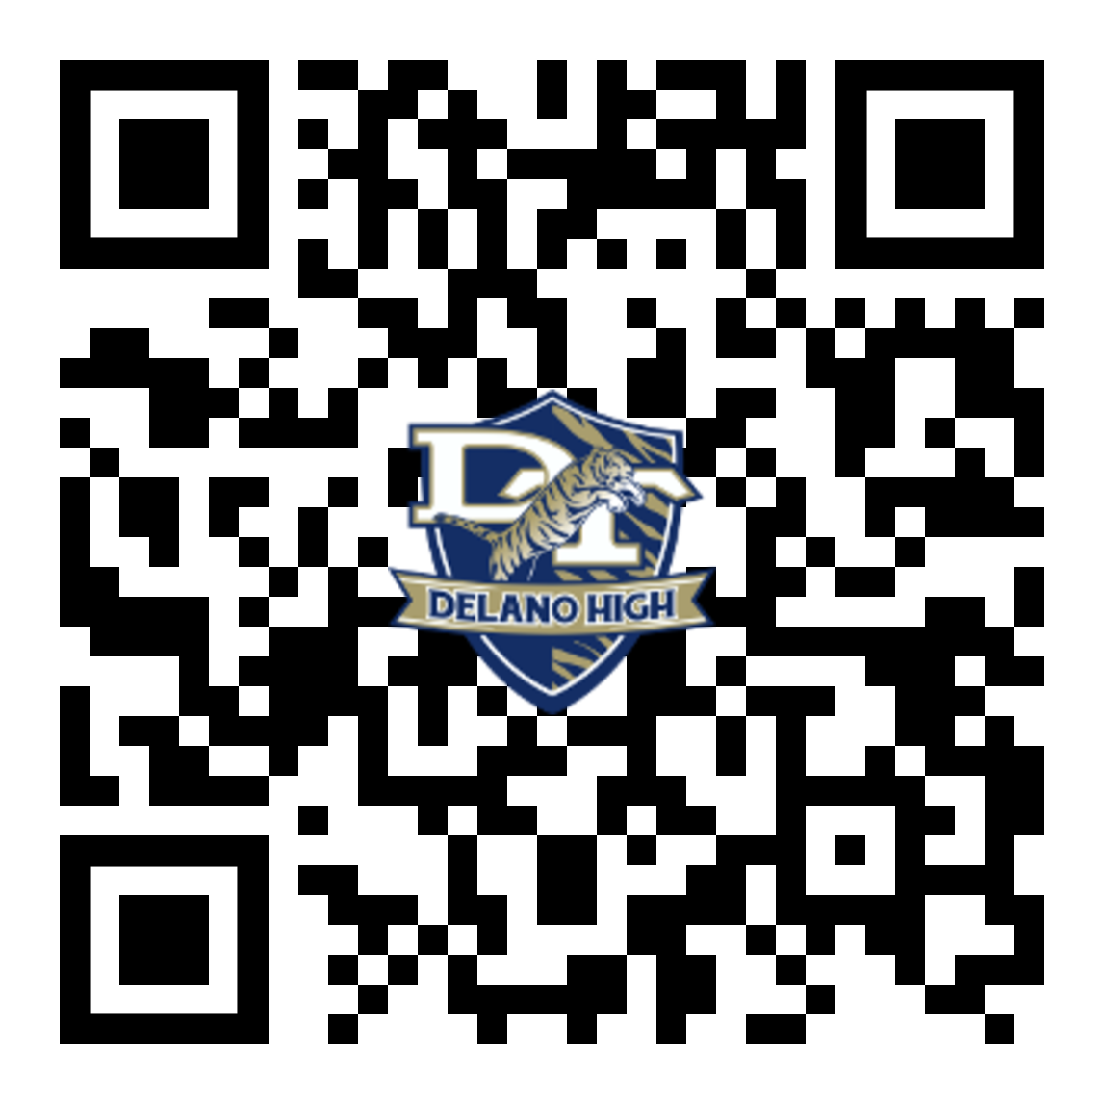 | DT Library  yOUR HUB TO INFORMATION AND tECHNOLOGY  MISSION  Delano High School is committed to providing every student a clean, safe,  and orderly environment which will foster maximum academic achievement, technological skills, social awareness, and personal growth.  VISION  Achieving Academic Excellence - A Student at a Time.
Services Available:  - Provide instruction and assistance in the use of library information, materials and equipment through a library orientation.  - Provide a quiet, safe, clean and orderly place that nurtures learning.  - Provide basic and essential support for all DHS students’ personal and academic growth.  - Provide recreational books, information and materials.  - Promote literacy and enable students to achieve academic standards and become lifelong learners.  - Purchase books and materials at different levels and in varying degrees of difficulty in order to be able to support the adopted school-curriculum, instructional programs, and entire student body.  - 1-Computer printer is available to students for printing one copy of documents, less than ten pages, and relating to school assignments.  - 28 computer workstations  - 30-iPad mobile cart | Computer Policies and Procedures:  - Students with school related assignments will have priority use. Students using the computers for recreational purposes or personal interest may be asked to log off so that students with school work may log on.  - Students with school related work may use the printers without cost for one copy of any document less than 10 pages. If there is a question or a problem, please bring it to the attention of the Library staff before sending the print command.  - Only one student may use/view a workstation at a time. Exceptions may be made with the Library staff when students have evidence of group projects or written requests from the teaching staff.  - Students are asked to log off once they are finished with their workstation.  - Students must not attempt to alter system folders, icons, or make any changes on the system.  - Students must follow the Internet Student Code of Conduct for the Delano Joint Union High School District.  - If there is a password issue, bring it to the attention of the Library staff. | Helpful Links:  The Kern County Library  http://www.kerncountylibrary.org/  The Walter Stiern Library at CSU Bakersfield  http://www.csub.edu/library/  The Bakersfield College Library  http://www.bakersfieldcollege.edu/library/  The Internet Public Library  http://www.ipl.org/  The Library of Congress  http://www.loc.gov/index.html  Purdue Owl  https://owl.english.purdue.edu  Federal Student Aide  https://fafsa.ed.gov/  College Board  https://www.collegeboard.org/

